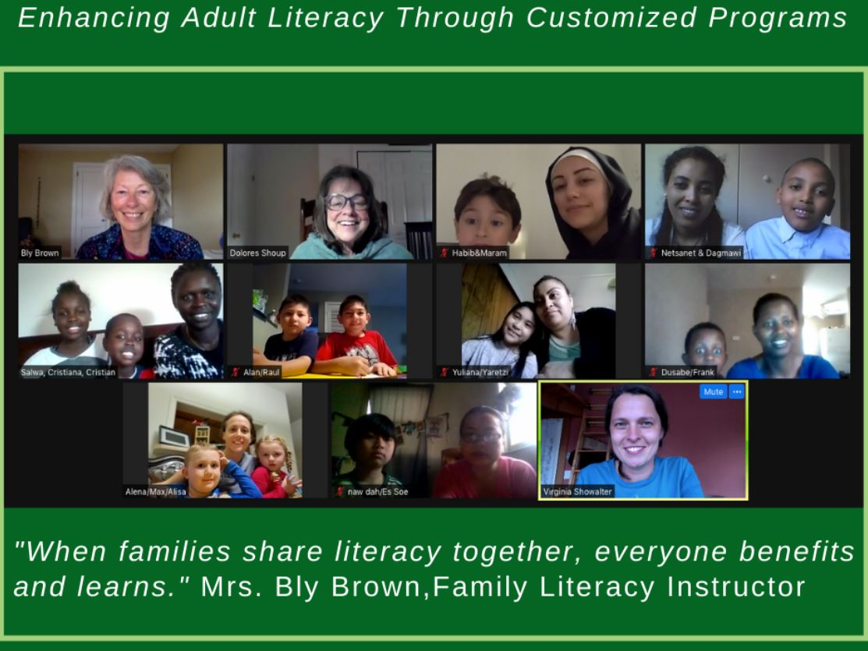
Living Together, Learning Together: Almas & Redas
For mother-daughter pair Almas and Redas, literacy is a family affair. When Redas and her husband moved their three daughters from Yemen to Harrisonburg a little over 7 months ago, they knew they wanted to get their family involved with English classes as soon as possible. “I enjoy the English classes very much,” Almas says. “My teachers are happy when I ask questions, they let me understand everything and take things slowly when I need them to”
While Redas and Almas are involved with Skyline’s beginner English courses for adults, the family has also found opportunities for family learning through Skyline’s Family Literacy Nights. These weekly virtual sessions consist of a read-aloud of a children’s book by one of Skyline’s volunteer teachers, a craft that goes along with the story, and a discussion/share time where parents and their children get to read the stories together and talk about what they’ve learned.

Every Tuesday night, Redas and her daughters (Almas, Remas, and Farah) log onto Zoom and listen, read, and learn alongside several other immigrant and refugee families in the Harrisonburg area. The Zoom format has been a great option for the family, as it's allowed them to learn from their home and participate in the class while Redas cares for a newborn at home. “We are learning new things” Almas says, “And getting to do it as a family, with other families… it gives us something to look forward to at the end of the day. It can be very isolating here, so the class has been good because we get to see other families and kids.”
In addition to providing a sense of community and connection, the Family Literacy Nights encourage new forms of bonding within the families themselves. “When we left Yemen, we could not bring children’s books with us” Almas says, “We don’t have any here in our house that are written in Arabic, so the literacy nights let us all read together.” Isolation has been difficult for the family over the last few months. While her husband is at work, Redas and the girls are limited to their home and neighborhood. Though things have been challenging, Skyline classes and resources have made the family excited for the future in many ways. Redas is excited to get better at English and one day find a job nearby to support her family. Almas, the oldest of the children, has big dreams as well. She practices her English skills at home every day and is in one-on-one conversational classes through Skyline. “I am hoping to get my driver's license soon so I can help my mom and be able to drive around” she says, adding that her long-term goal is to go to university and be a nurse or doctor. “I like to help people, to make them happy and feel good.”

